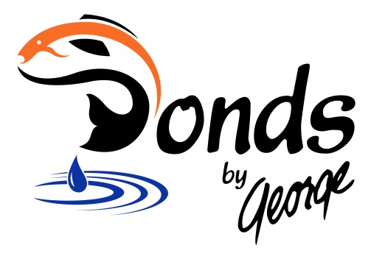
Ponds By George
1855 Street Road Southampton, PA 18966
Store # 215-396-7500
Cell # 267-240-4982

CALL US TODAY
And mention the coupons below for Big Savings!

Buy Any 3
Potted Aquatic Plants
And Get $10 Off
Expires June 30, 2019
Or

Buy 3
Water Hyacinths or Lettuce
And Get One Free
Expires June 30, 2019

